

REACT JS PROJECT REPORT ON
TITLE OF THE PROJECT

Submitted by
NAME: Vignesh V
REGISTER NO: 24BIT160

Under the Guidance of
Trainer Name: Aravindh
Technical Trainer
Technical Department, KG College of Arts and Science

Academic Year: 2025 – 2026
APRIL 2026

DECLARATION
I hereby declare that the project entitled “Blood bank management system” submitted in partial fulfillment of the requirements for the course React JS is a record of my original work carried out under the guidance of Aravindh, Technical Trainer, Technical Department, KG College of Arts and Science.
I further declare that this project has not been submitted previously, either in part or in full, for the award of any degree, diploma, or other similar title, at this or any other institution.
I have acknowledged all sources of information used in this project wherever applicable.

April 2026
Coimbatore

________________________
Vignesh V

CERTIFICATE
This is to certify that the project entitled “Blood bank management system” is a bona fide work carried out by Vignesh V [2024 batch], Department of Information Technology, KG College of Arts & Science, in partial fulfillment of the requirements for the course React JS.
This project has been completed under my supervision and guidance during the academic period April 2026.

Place: Coimbatore
Date:16/04/2026

Submitted for the Viva-Voce Examination held on 16/04/2026

Guide: Head of the Department
(Technical Trainer, KGCAS) (Technical Head, KGCAS)

Aravindh Boopalan

TABLE OF CONTENTS
S. No. | Topics | Page. No.
1 | Introduction
1.1 | Background of the Study
1.2 | Problem Statement
1.3 | Objectives of the Project
1.4 | Purpose and Significance
1.5 | Scope and Limitations
1.6 | Methodology Overview
2 | System Analysis
2.1 | Existing System
2.2 | Drawbacks of the Existing System
2.3 | Proposed System
2.4 | Features of the Proposed System
2.5 | Feasibility Study
2.6 | Requirement Analysis
3 | System Design
3.1 | System Architecture
3.2 | Use Case Diagram
3.3 | Data Flow Diagram (DFD)
3.4 | Entity Relationship Diagram (ERD)
3.5 | User Interface Design
4 | System Implementation
4.1 | Development Tools
4.2 | Module Description
4.3 | Algorithms
4.4 | System Integration
4.5 | Security and Validation
5 | System Testing
5.1 | Testing Methodology
5.2 | Test Cases
5.3 | Error Handling
5.4 | Performance
6 | Input and Output Screens
6.1 | System Outputs
6.2 | Discussion
6.3 | Comparison
6.4 | User Feedback
7 | Conclusion and Future Enhancement
7.1 | Summary
7.2 | Limitations
7.3 | Future Scope
8 | References
Appendices
- Source Code Snippets
- Screenshots of Web Pages

ABSTRACT
The Blood Bank Management System is a web-based application developed using the MERN stack (MongoDB, Express.js, React.js, and Node.js) to efficiently manage blood donation, storage, and distribution.
This system allows donors to register and donate blood, hospitals to request blood units, and administrators to manage inventory. The application ensures real-time updates of blood availability, secure user authentication, and efficient tracking of donor and recipient data.
The project aims to improve the efficiency of blood bank operations by digitizing manual processes and providing a centralized platform for managing blood-related information. It demonstrates the use of modern web technologies to solve real-world healthcare problems.

Chapter 1: Introduction
  - Background of the Study
Blood is a critical resource in healthcare, and timely availability can save lives. Traditional blood bank systems rely on manual record-keeping, which can lead to delays and inefficiencies.
With advancements in technology, web-based systems can improve blood management by providing real-time updates, better data organization, and faster communication between donors and hospitals.

  - Problem Statement

Existing blood bank systems face challenges such as:
- Manual record maintenance
- Lack of real-time blood availability
- Difficulty in finding donors quickly
- Inefficient communication between hospitals and blood banks

1.3 Objectives of the Project
• To develop a web-based blood bank system using MERN stack
• To manage donor and blood inventory data efficiently
• To allow hospitals to request blood units
• To provide real-time blood availability updates
• To ensure secure authentication using JWT.

1.4 Purpose and Significance of the Study
This system helps:
- Save lives through faster blood availability
- Reduce manual workload
- Improve transparency in blood management
- Enable efficient donor-hospital interaction

  - Scope and Limitations
Scope:
• Donor registration
• Blood stock management
• Blood request system

Limitations:
• No integration with real hospitals (prototype)
• No emergency GPS-based donor search
• Limited scalability without cloud deployment

1.6 Methodology Overview
The project follows a structured Software Development Life Cycle (SDLC) approach.
  - Requirement analysis
  - System design
  - Development (MERN Stack)
  - Testing
  - Deployment

Chapter 2: System Analysis
2.1 Existing System
• Manual blood records
• Phone-based communication
• Paper-based donor details
2.2 Drawbacks of the Existing System
• Time-consuming
• Data inconsistency
• No real-time updates
• Difficult tracking
2.3 Proposed System
The proposed Blood bank management system provides a centralized, interactive platform where students can browse about pickup and drop location.
• Stores donor and blood data
• Allows blood requests
• Updates availability instantly
• Provides secure access

2.4 Features of the Proposed System
• Donor Registration & Login
• Blood Stock Management
• Blood Request System
• Admin Dashboard
• Real-time updates.

2.5 Feasibility Study
Technical Feasibility:
The project uses lightweight, open-source technologies —MERN Stack— efficient and scalable development
Economic Feasibility:
Development cost is minimal since it uses free tools and requires no paid hosting or licensed software for the prototype version.
Operational Feasibility:
The system is simple, intuitive, and requires no special training to operate, making it easy for students and educators to adopt.

2.6 Requirement Analysis
Functional Requirements:
• Register donors
• Add blood units
• Request blood
• View availability
Non-Functional Requirements:
• Security (JWT)
• Fast performance
• Responsive UI

Chapter 3: System Design
3.1 Introduction
System design defines the overall architecture, structure, and data flow of the project. It translates the requirements gathered during the analysis phase into a blueprint for implementation. For the Blood bank management system, the design focuses on the interaction between users, web pages, and data components that together deliver course content and quizzes effectively.

3.2 System Architecture
The system follows a three-tier architecture:
- Frontend: React.js
- Backend: Node.js + Express
- Database: MongoDB

3.3 Use Case Diagram
1. What is a Use Case Diagram?
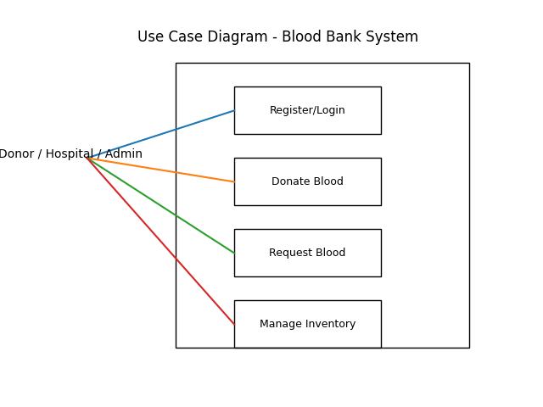
Actors:
- Donor
- Admin
- Hospital
Use Cases:
- Register/Login
- Donate Blood
- Request Blood
- Manage Inventory
- View Reports
A Use Case Diagram visually helps you explain “Who does what” in your system.

- Data Flow Diagram(DFD):
Level 0:
User → Blood Bank System → Database
Level 1:
• Donor Registration
• Blood Storage
• Blood Request Processing
• Inventory Management
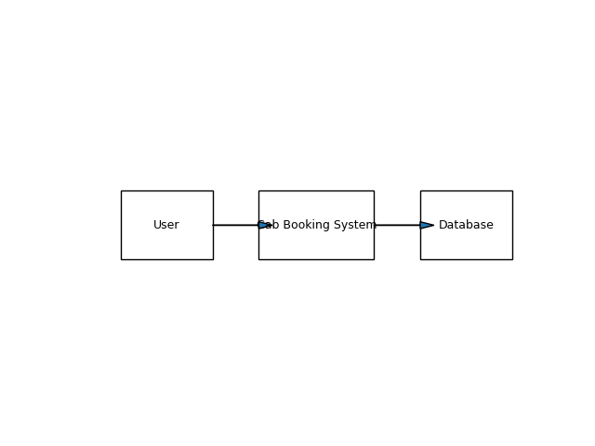

4. Define Relationships
Entities:
• Donor (donorId, name, bloodGroup)
• Blood (bloodId, group, quantity)
• Request (requestId, hospital, status)
Relationships:
- Donor donates Blood
- Hospital requests Blood

5. Draw the Diagram (Structure Example)
Tools you can use:
- draw.io (free online)
- Lucidchart
- StarUML
- MS Visio
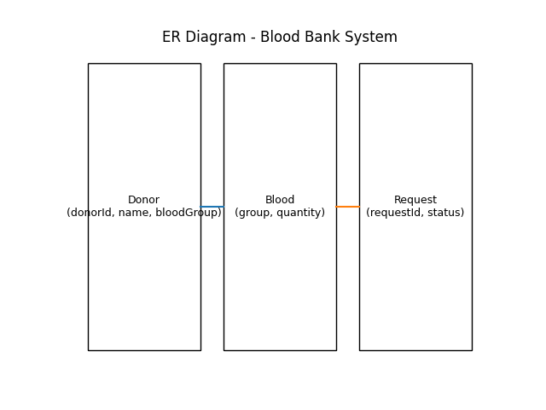

7. Step-by-Step (Using draw.io)
- Go to https://app.diagrams.net
- Choose a blank diagram → name it “Use Case Diagram”.
- From the left panel, drag:
  - Stick figures → represent Actors.
  - Ovals → represent Use Cases.
  - Box → system boundary.
- Connect Actors ↔ Use Cases using lines.
- Label relationships (<<include>> / <<extend>>).
- Export as .PNG / .JPG and insert into your documentation.

Chapter 4: System Implementation
4.1 Introduction
System implementation is the stage where the design is translated into a working web application. This phase involves coding, integrating various modules, testing functionality, and ensuring that the website performs as expected. The Blood bank management system is implemented using front-end technologies React JS and MERN stack to provide an interactive and responsive learning platform.

4.2 Development Tools and Technologies
Tool / Technology | Purpose
React JS | Frontend UI
Node.js | Backend runtime.
Express.js | API handling
MongoDB | Database
Browser (Chrome / Edge) | Used for execution and debugging of the web application.
Visual Studio Code | Code editor for development and testing.

4.3 System Modules Description
Module
Authentication Module
Donor Module
Blood inventory Module
Request Module
Admin Module

4.5 Algorithm / Logic of Core Function
Algorithm for Blood request:
  - User selects blood group
  - System checks availability
  - If available → approve request
  - Else → show unavailable

4.6 Security and Validation:
- JWT authentication.
- Input validation.
- Protected one.

4.7 Integration
All modules are seamlessly integrated using event-driven programming. Frontend communicates with backend APIs using Axios.

Chapter 5: System Testing
5.1 Introduction
System testing is a crucial phase that ensures the developed application meets all functional and non-functional requirements. It validates whether the system performs as expected under various conditions. For the Blood bank management system, testing was conducted to verify the functionality of modules, including course display, lesson navigation, quiz evaluation, and result generation.

5.2 Test Cases:
Test ID | Module | Expected Result
T01 | Login | Successful login
T02 | Donor | Donor added
T03 | Request | Request processed
T04 | Inventory | Correct stock

5.3 Types of Testing Performed
a) Unit Testing
Each JavaScript function and webpage component was tested independently. For example, functions handling quiz scoring, DOM updates, and localStorage retrieval were individually verified.
b) Integration Testing
After unit testing, all modules were combined and tested as a whole to ensure that navigation between pages worked without errors.
c) System Testing
The complete web application was tested to ensure all functional requirements were met — including quiz evaluations, course listings, and responsiveness.
d) User Acceptance Testing (UAT)
The system was demonstrated to sample users to gather feedback. The website’s layout, speed, and usability were reviewed, and suggestions were implemented where necessary.
e) Cross-Browser and Device Testing
The system was tested on popular browsers such as Google Chrome, Mozilla Firefox, and Microsoft Edge, and on devices like laptops, tablets, and mobile phones to ensure responsiveness.

5.6 Error Handling
- Invalid login alerts
- API error handling.
- Input validation.

5.7 Performance and Usability Testing
- Performance: Page load time was under 2 seconds in standard browsers.
- Usability: Students found the website easy to navigate, visually clear, and responsive.
- Accessibility: The system supports keyboard navigation and uses readable font styles for better visibility.

5.8 Results and Observations
All modules functioned as expected. The website performed well on multiple devices, and user feedback confirmed that it was interactive and efficient. No critical defects were identified in the final round of testing.

Chapter 6: Results and Discussion
6.1 Introduction
This chapter presents the practical results obtained after implementation and testing. It demonstrates how each module of the Blood bank management system performed during execution and how well the system met its stated objectives.

6.2 System Outputs
During execution, the system produced the following key results:
- Homepage: Displaying successful login with short descriptions.
- Blood stock updated
- Request processed

6.3 Performance Analysis
- Responsiveness: Average page load time < 2 seconds.
- Accuracy: blood request logic achieved 100 % logical accuracy.
- Stability: No runtime or data-handling errors during repeated trials.
- Cross-Browser Compatibility: Verified on Chrome, Edge, and Firefox with consistent results.

6.4 User Feedback
A small group of student users tested the prototype. Feedback indicated:
- Simple and intuitive navigation.
- Helpful system.
- Needs mobile app.

Chapter 7: Conclusion and Future Enhancement
7.1 Conclusion
The Blood bank management system project successfully demonstrates how modern web technologies can be applied to create an interactive and accessible learning platform. By utilizing MERN stack development the system offers a responsive interface that enables users to login, request for blood, know about the blood stock.
The project achieved its primary objectives of delivering a simple, user-friendly, and dynamic web application . Testing confirmed that all modules operate efficiently and reliably. The system meets functional and non-functional requirements such as usability, portability, and responsiveness.
This work highlights how front-end web development can support the goals of blood bank management system by combining functionality, design, and accessibility. It also serves as a strong foundation for future expansion into a complete online blood bank management system.

7.2 Limitations
While the system meets its core goals, the current version has a few limitations:
• No real-time donor tracking
• No hospital integration
7.3 Future Enhancement
The project can be enhanced and scaled in several ways:
- GPS-based donor search
- Mobile app
- AI-based prediction
- Cloud deployment

Chapter 8: References
  - MDN web docs
  - MongoDB documentation
  - React Documentation
  - Node.js documentation

Appendices
Appendix A – Source Code
Include your main source files:
- Client/ - frontend developments
- Server/ - backend development
- Models/ - mongoDB connection
(Attach or paste formatted source code snippets here — only essential parts, not full-length code, to maintain report readability.)
Appendix B – Screenshots of Web Pages
Attach labeled screenshots with captions:
- Figure 1.1: Login page.
- Figure 1.2:Blood request page.
- Figure 1.3: Available blood stock.
- Figure 1.4: status of the blood request.
(Ensure all figures are captioned and referenced in your text, e.g., “Refer to Figure 1.3”).
Appendix C – User Manual / Installation Guide
Steps to Run the Project:
- Download all project files .
- Place them in the same folder.
- Open the links given in the terminal in any modern browser (Chrome, Firefox, Edge).
- Browse the required blood group, ,check status of the blood request
- Check your result displayed instantly on the page.
System Requirements:
- OS: Windows / macOS / Linux
- Browser: Latest Chrome or Firefox
- RAM: Minimum 2 GB
- Storage: 100 MB free

